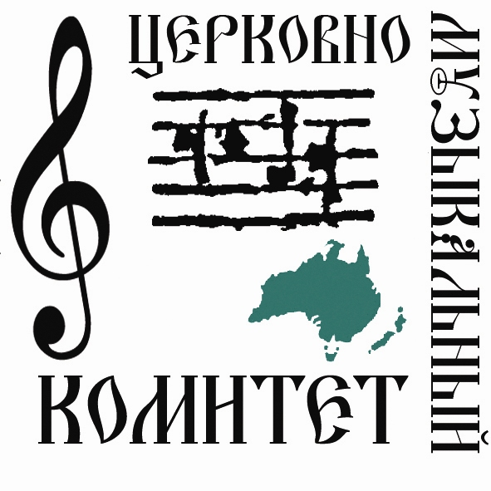
Australian and New Zealand Diocese of the Russian Orthodox Church Outside of Russia
5th CHORAL CONFERENCE REGISTRATION FORM
2-6 JULY 2008, STRATHFIELD/CABRAMATTA

Name / Имя Surname / Фамиля

Address / Адрес Email / Електр. Почта

City, state / город, штат Telephone (hm.) / телефон (дом.)

Post code / почт. Код Telephone (mob.) / телефон (моб.)

Please indicate the appropriate category
Пожалыйста отметьте относящияся к Вам категории

□ choir conductor / регент □ soprano / сопрано □ bass / бас
□ reader / псоломщик □ alto / альт □ basso-profundo / октава
□ singer / певчий □ tenor / тенор

Your parish / Ваш приход:___________________________________________________________________

WILL YOU NEED TO BE BILLETTED (Y/N)? __________

HAVE YOU MADE OWN ARRANGEMENTS FOR ACCOMMODATION (Y/N)? __________

COST FOR THE CONFERENCE WILL BE $100. THIS COST WILL INCLUDE EVENING/LUNCH MEALS AND ONE TICKET TO THE END OF CONFERENCE CONCERT AT ST JAMES CHURCH SYDNEY CBD, SUNG BY THE FESTAL MALE CHOIR OF ST DANIEL’S MONASTERY (MOSCOW).

WHAT ACTIVITIES/WORKSHOPS WOULD INTEREST YOU MOST?
□ CONDUCTING TECHNIQUES □ PODOBNY/SPECIAL MELODIES
□ THE 8 TONES □ BELL RINGING
□ VOCAL TECHNIQUE □ LITURGICAL MUSIC INTERNET RESOURCES
□ OTHER _______________________________

Cheques payable to: 5th ROCOR CHORAL CONFERENCE

Completed registration forms together with payment may be mailed to:
Andrei Laptev, 31 Ilka St, Leichhardt, NSW, 2040
Email: andreilaptev@yahoo.com.au

